**Build on Concepts (BoC) Site Report 2  
Student Name: Ronniel B. Dizon  
Date: 10/24/2018**

**Website URL: http://cis2.oc.ctc.edu/class/ag155.fall18/ronnieldizon/BoCs/BoC2/BoC2/home.html**

Use the check list below to work through the tasks for BoC2. Note that line numbers or other indications are *required* and points will be deduct if they are not present (since if you don’t tell me where to locate the item, it may not be done).

Also complete the section after the checklist showing your wireframe, validation, site URL, and screen rendering of your site.

Do not upload this file to cis2; only submit it to Canvas.

|  |  |  |  |
| --- | --- | --- | --- |
| **Check if Done** | **Task** | **Where in the code is it found (line number or other indication) – use NA if not applicable** | |
| **Set up your BoC2 site root and a new page to code:** | | | |
|  | Copy all the files from your BoC1 site root directory on your local system into the BoC2 site root directory on your local system. Make sure you are working with a copy of the original BoC1, not pointers to those files. Your original BoC1 should remain as is. You will work with a fresh copy of the files. | NA | |
|  | Open **home.html** and **the additional HTML file** from the BoC2 site root in your text editor. You will modify both. | NA | |
|  | Load home.html in a browser, and select one of the links on the left-side navigation as the topic for a new page that you will develop. You can pick any one of them, excluding Home and Contact/About Me, since you already coded those pages. | NA | |
|  | In your text editor create a new HTML file from scratch to add to your local site, and save it as an HTML file to the BoC2 site root. You can name it whatever makes sense to you; just be sure it has no spaces, and preferably uses only lower-case characters. Make sure it uses the html file extension. | facts.html | |
|  | Create the basic structure of an HTML document that includes properly-nested elements for head and body, and declares the doctype for HTML5. Code at least 3 meta elements and a title that reflects the new page (be careful not to make them identical unless that is appropriate – author is, description is not). Make sure that the head and body are nested within the html tags (don't forget your closing html tag) and that all head content is complete. | facts.html;  Line: 5, 6, 7 | |
|  | Link your new html file to the two CSS files (sb.css and your sbstyles.css CSS file). | facts.html;  Line: 20, 21 | |
|  | Be sure your name and the date are in the comments at the top of the document. | facts.html;  Line: 12, 13 | |
|  | Duplicate the nav and header content onto your new page (do not confuse header and head--header is part of the page body that appears at the top of the page in the browser). You can do this by copying the top part of the body code from the top of the nav to the bottom of the header (the same as you did for the contact page); you want to capture all page elements that pertain to the top of the page so that there is consistency on the pages. Make sure you do not copy any other page content. Paste this at the top of your new page just under the opening body tag. | facts.html;  Line: 4 - 36 | |
| **Generate new content:** | | | |
|  | Based on the topic of your selected page, generate content for the page that includes text and images. You can create the content or find some you can use with a cited source; see instructions on sourcing material in the course shell. You aren't being graded on the content, but rather on content delivery. You can create it or research to find something pertinent to your page's topic, which you can copy and paste.  Please note the plagiarism and copyright discussion in the “creating content” link on the assignment page in Canvas. Ask if you aren’t sure. | facts.html;  Line: 39-53 | |
| **Create a wireframe:** | | | |
|  | Think ahead on how you want your new page to look using your content with all the requirements as noted below. You'll need to read the requirements below before you plan and sketch the wireframe. Create a wireframe for your new page.  Add an image of the wireframe after this table (a screenshot, photo of a sketch, or scanned image). | Attachment provided | |
| **Add new content, structure, and styles to the new page:** | | | |
|  | Use your wireframe as a guide, and create a new main section element for your new page into which you will add the content that is based on the topic of the navigation item you selected. The specifics of the page design are up to your imagination and skill, but must include the following features: |  | |
|  | Two or more structural elements *nested within the main area* (recall that a structural element provides a layout box—see figure 1-11 on page 24 as a review). You will add most of your new page’s content to these distinct areas. | facts.html;  Line: 40, 41, 47, 53, 54 | |
|  | Add new content to the elements above. Add whatever you find useful for the content of your new page. | facts.html;  Line: 40 - 60 | |
|  | Apply an image map to an image on your new page. Target a particular part for the hotspot, not the entire image. You can use any shape you wish as long as it provides adequate coverage of the intended hotspot. There needs to be at least one link in the image, and something in the text informing the user that it is available (not an “easter egg” for them to discover). | [Attempted but still need assistance] | |
| The following style features focus on **layout**. That means they target the structural HTML elements (the boxes that surround your content). The style properties below will adjust box sizes and placement.  Use your CSS file to apply the following layout to your newly-added structural elements--do not modify the header or nav with your new layout styles. This may mean you will need to use IDs or Class attributes to distinguish page parts.  Add a clearly-defined comment for this new part to the CSS file, and ensure that any new styles you add to this page do not clobber any other of the existing pages!  Apply the following layout styles to your new page using your CSS file: | | | |
|  | Display property (page 172) | Line 129, 136, 152 | |
|  | Width and height style properties with overflow instructions (page 240) | Grouping 109 | |
|  | Floated elements and cleared elements (page 183) | [Attempted but not working. Need refresher] | |
|  | Rounded or elongated corners (page 277) | Line 127 | |
|  | A tiled or non-tiled background image (page 265) | Line 17 | |
|  | Relative and/or absolute positioning (page 226) | [Need assistance] | |
|  | Both fixed and fluid units of measure (page 176) | [Not sure how to work this] | |
| Embedded styles:  Embedded styles are described in tutorial 2 beginning on page 86. Recall that these types of CSS styles are placed between the opening and closing <style> tags in the head part of the document. Embed these on your new page. | | | |
|  | Embedded CSS gradient style: Create or select an element on which to apply a background color that uses a gradient effect. | Line 117 | |
|  | Embedded CSS transform style: Create or select an element on which to apply a transform and/or transition effect. | Line 132 | |
|  | Add comments in your CSS document that indicate where these new styles are added and describe what they should do. |  | |
| **Finish coding the site:** | | | |
|  | In all three of the HTML documents, create hyperlinks in the navigation that point to the new page. All navigation links should be working on all three pages the same way. |  | |
|  | Verify that ALL links are working to reflect the new site’s references and sources. |  | |
|  | Verify that your newly added styles did not clobber any of the styling from previously created pages—fix any issues you find. |  | |
|  | Create comments that indicate where your new styles are added in--use your best judgement and make the comments meaningful and helpful for following your code in the CSS. Be sure your name is in the comments at the top of all coded pages. |  | |
|  | Be sure that your HTML and CSS code is structured and formatted to properly reflect the nested structure. Note how that was done in the box to the right. | 1. Body Styles 2. Site Navigation 3. Header 4. Main Section 5. Home specific 6. Facts specific 7. Contact specific |
|  | Be sure that your HTML and CSS code is commented to explain its organization and content appropriately. This applies to all new code in existing HTML pages, the new HTML page, and the updated CSS file. Note how that was done in the box to the right. | Displays intended actions per commented section |
|  | Test your code in several browsers to make sure it renders correctly. Note any particular browser issues in the box to the right. |  |
|  | Run your code through a HTML and CSS validators to ensure it is valid HTML and CSS. Though browsers will try hard to render all of your content, and may display it correctly, invalid code will result in deductions. Add screenshots of the validation output (three HTML files and the modified CSS file) in this document below. Note there should not be any validation errors, and contact me about any warnings to see if they should be cleared up. | Known error for the Marquee effect. Keeping until Ch8. |
|  | Upload your files (HTML, CSS, and images) to cis2 and ensure that it still renders correctly and that there are no missing or misnamed files (case matters!). Test all links. Include the URL and screen shots of your pages (including the browser address bar) below. |  |

This is another long list of tasks, but each task is small. Process through the list step-by-step. All tasks are derived from the module readings and practice. If you are unsure how to do one of the tasks, move on and come back to it later. You will find these tasks covered in the module material. Ask for help as needed. Be sure to comment well here and in your code, to ensure your work can be properly graded!

# Wireframe for BoC2:

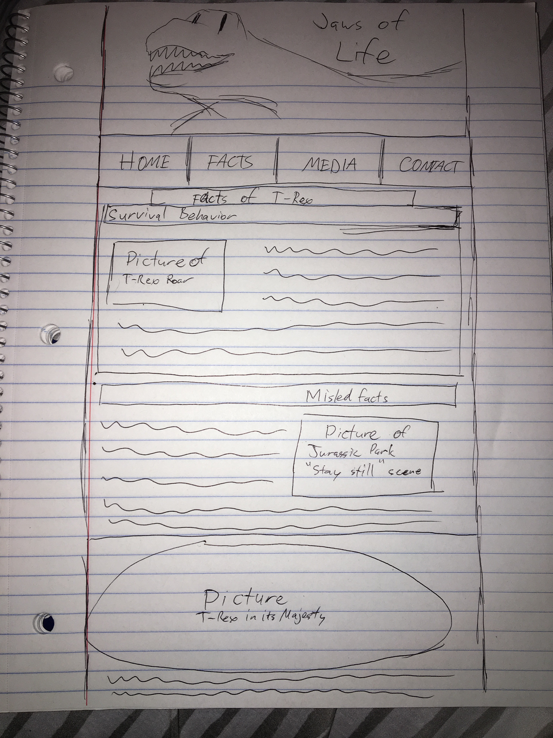

# Validation Screenshots:

HTML

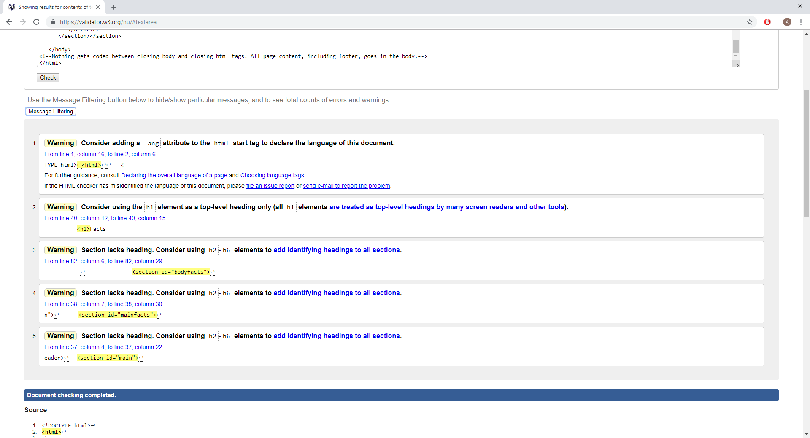

CSS

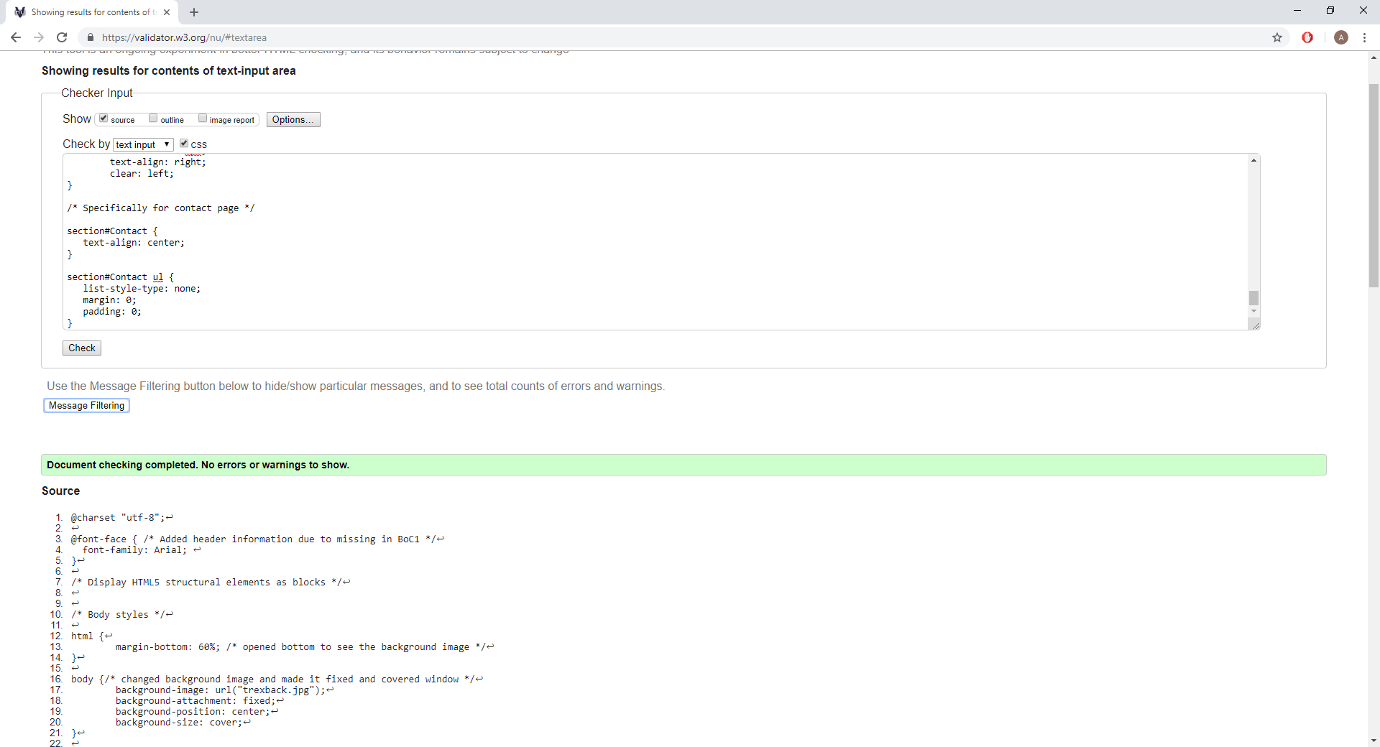

# URL to your site:

Complete this URL with your cis2 home page for your BoC1 submission. This is the address you type in to the browser to get to your site’s home page. Note, you won’t be able to “drill down” from the cis2 class page since you secured your home directory with an index.html file. You must construct this URL by adding your folders and the home page file name to your personal URL on cis2.

http://cis2.oc.ctc.edu/class/ag155.fall18/ronnieldizon/BoCs/BoC2/BoC2/home.html

# Rendered Site Screen Shots:

Add screen shots of your rendered site here; these need not be the “full page”, but should show the full browser window with the URL visible in the browser’s address bar, and the top portion of the page typically visible in a standard PC layout.

Include screen shots of all pages added or altered since BoC1. If an existing page’s source HTML or CSS have changed, a screen shot is needed, even if the CSS file is a separate file from the HTML.

Internet Explorer

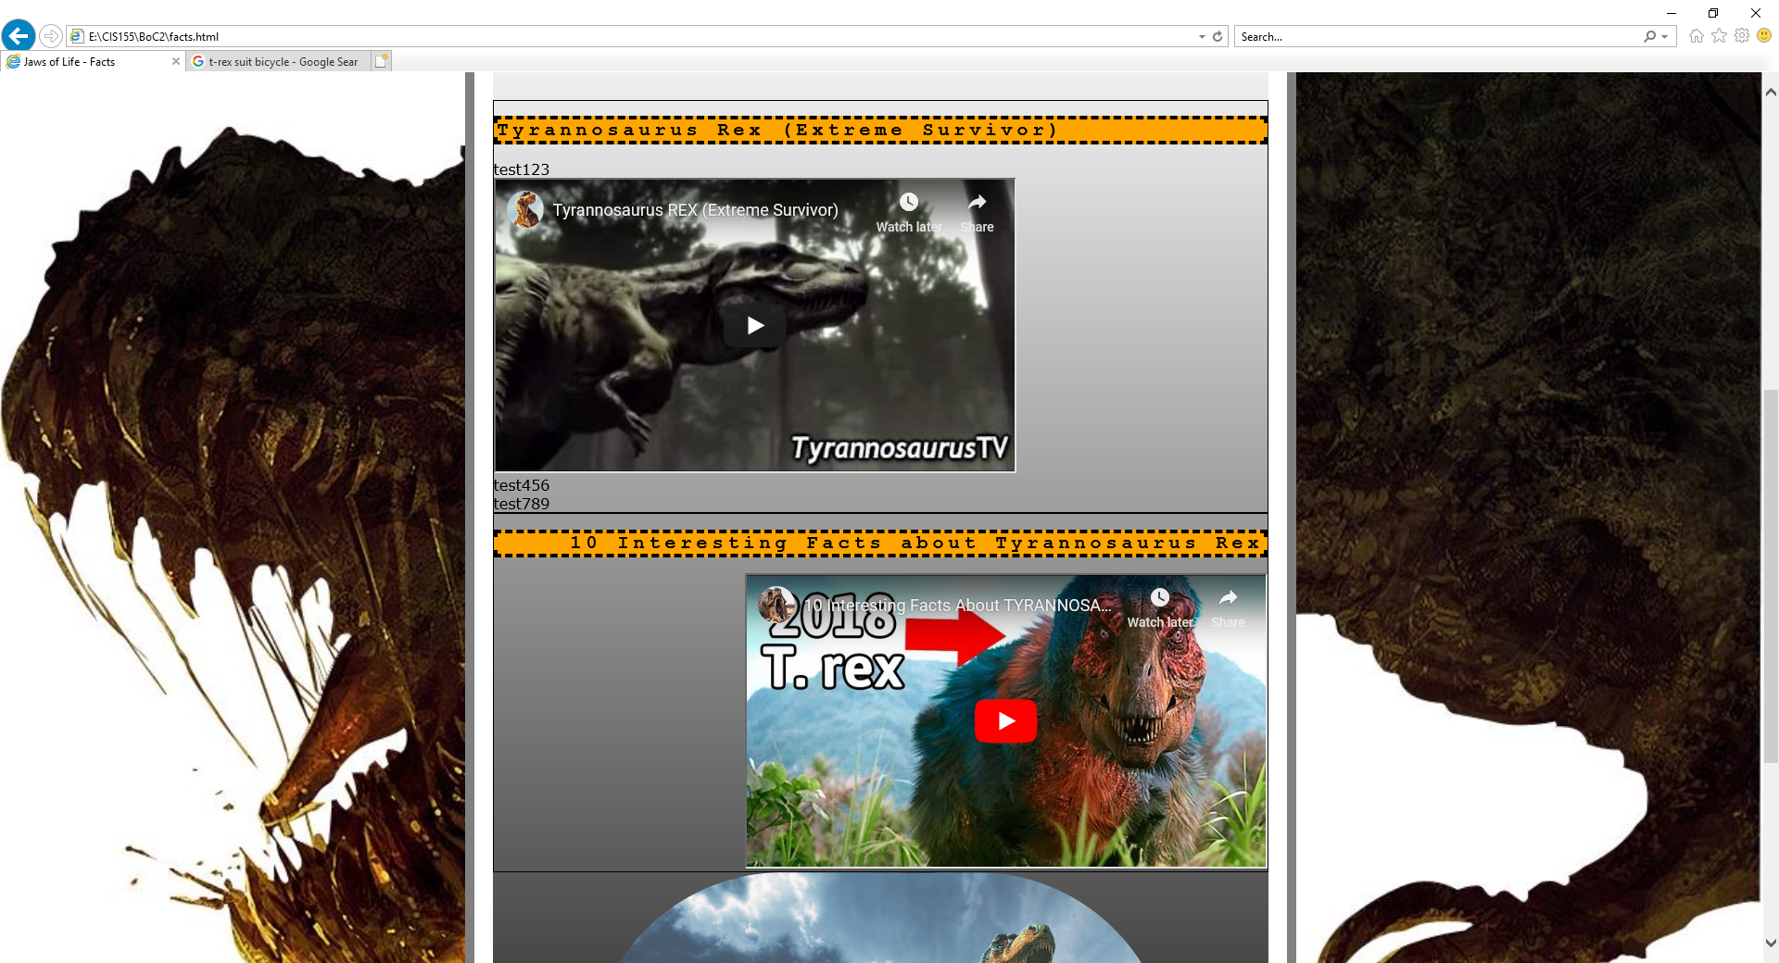

Google Chrome